Please start by saving this file with the name: GUID_Surname_ENG5059P_Prelim_year

Please tick appropriate project:

ENG5059P (MSc) | √

Student Name | Chenyao Sun
Student GUID Number | 2638310S
Degree programme | ENG5059P: MSc Project
Working Title of Project | Understanding microbial activity of biological and chemical dispersants of crude oil
Name of Supervisor(s) | Umer Ijaz
Academic year | 2021-2022

Introduction (max 1 page)

There have been many serious oil spills in the frequent offshore oil transportation and exploitation. The oil can spread hundreds of miles and kill the seabirds, mammals and other organisms they coat. In addition, the oil film formed by oil on the sea surface can hinder the gas exchange between the atmosphere and seawater, which has a potential impact on long-term climate change.

Oil is typically degraded by the activity of hydrocarbon-degrading (hydrocarbonoclastic) bacteria in the oceans. Recently, understanding the role of these bacteria, particularly in response to the use of chemical surfactants, has gained popularity. Chemical surfactants, although effective, are not eco-compatible and pose a significant environmental risk. For example, petroleum hydrocarbons dominated by aromatic hydrocarbons cannot be decomposed into aquatic organisms and form carcinogens after enrichment through the food chain.

This project will compare the performance of Finasol, a globally stockpiled chemical dispersant for treating oil spills at sea with Rhamnolipid, a natural biosurfactant that is more environmental friendly. For both types of surfactants, microbial community surveys through 16S rRNA amplicons are available. The structure and dynamic changes of the marine microbial community under these two different dispersants will be studied. Data analysis and diversity investigation will be conducted on the dominant bacterial colony under different treatment methods. The project is guided by the recent technological advancements in microbial in situ omics data analytics.

Aims/Objectives of project

Calculate microbial communities' diversity and dynamic changes under different dispersant treatment methods. Reveal the interaction mode between microorganisms and the environment in the treatment and how they affect the response of oil-degrading bacteria.

Resources required
- Dataset
- R and R studio
3. Sample statistics of water accommodated fractions
4. Paper references

GANTT chart
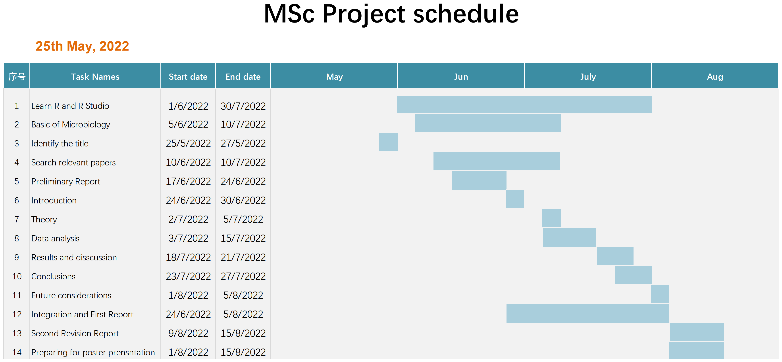

Risk assessment

1.Risk: Unavailability of data
Likelihood without control measures: Improbable
Severity: Slight
Control measures to mitigate risk: The data for the project is provided by the supervisor, and is available on a shared repository as well as a backed up
Likelihood with control measures: Improbable

2.Risk: Data corruption
Likelihood without control measures: Unlikely
Severity: Moderate
Control measures to mitigate risk: The project data is provided on a Dropbox repository (which maintains history for 30 days), as well as saved as a local copy on personnel computer, and in the event of data corruption, the extra copies will be used
Likelihood with control measures: Unlikely

3.Risk: Mental fatigue
Likelihood without control measures: Likely
Severity: Moderate
Control measures to mitigate risk: The project involves support of additional volunteers (who are PhD students/PDRAs associated with the supervisor's lab), as well as benefits from working in a team environment, with specific and measurable weekly milestones, ensuring the work is balanced in the duration of the project. The training and support is provided by the supervisory team, and access to statistical tools (existing programming codes from numerous projects) ensures reduced anxiety and concerns.
Likelihood with control measures: Likely

